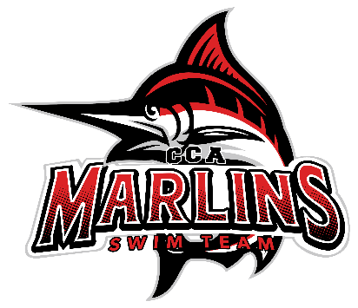

Marlins Board Meeting Minutes Recap (7/22/25)
Attendance: Brooke, Buffy, Juliet, Whitney, Julie, Steven, Jamie, Amina, Susan
1. Finances
Julie:
- The team made $9,987 at the Districts!
- Amina and Julie will collaborate on the Short Course budget.
- Increased the Tudor House donation to two lanes this year.
- Plans to increase Tudor House donations further next year.
- A financial report will be provided soon.
2. Coaches Update
- Coach Buffy: Similar to last month; currently has a heavier male roster, and everything is going well.
- Coach Jamie: The Bronze group is going well; several Mini and JAG swimmers have moved up.
- Coach Amina: Similar update as last month for Coach Casey's group.
- Coach Steven: Good turnout in the Senior and Gold groups.
- Coach Susan: Mini group has 6-8 kids attending every Tuesday and Thursday. Some Mini swimmers participated in the district meet, which was very enjoyable.
3. Recap of Districts
- Made $9,987 with approximately 50 fewer swimmers than the previous year.
- Received compliments on how the meet was run, along with a few suggestions for future improvements.
4. Anything Else
- Swim Lessons:
- Susan attempted several options for lessons but found them time-consuming and challenging to track. They will not continue with that method this fall.
- Susan, Steven, and Amina are planning a brainstorming session to streamline the lessons.
- Lighting Policy:
- Amina has prepared the policy, which will be included in the Short Course registration packets, along with the new Lockdown policy and Out of Schedule Meets policies.
- Registration:
- Returning swimmer registration is set to begin on August 1 or 3.
- Steven will send out communications after the Age Group events.
- Scheduling:
- Steven, Susan, and Jamie are meeting to plan schedules for Mini and Bronze days.
- Steven and Susan will discuss the Lancer Lot schedule.
- Steven will communicate the Open House dates to parents.
- Coaches Meeting:
- Coaches are planning to meet to discuss assessment dates and other schedule items.
- Parent Meetings:
- An in-person parent meeting is scheduled for September 7, with Swim & Tri immediately following.
- Additional parent meetings in January and late February will be virtual.
- Survey:
- The Board is working on a survey to be sent out at the end of the Long Course season.
- Short Course Meet Schedule:
- Discussion on the Short Course meet schedule. Steven is emailing about a few meets of interest that the team hasn’t attended recently, and Buffy is reaching out to another team to confirm November meet dates.
Next Meeting: Scheduled for August 19, 2025, at 8:30 (virtual)

